Questionnaire

Rooftop Solar Project Title:

Project Developer/Investor:
Address: | Company:
 | City:
 | Street:
 | GPS Coordinates:
Contact Person Details: | Name & Designation:
 | Phone:
 | E-Mail:

COMPANY DESCRIPTION

Industrial Sector:
☐ | Industry | ☐ | Electricity Supply
☐ | Agriculture | ☐ | Water Supply / Disposal
☐ | Forestry | ☐ | Gas Supply
☐ | Fisheries | ☐ | Service Company
☐ | Tourism | ☐ | Construction
☐ | Education | ☐ | Health
☐ | Trading | ☐ | Others:

Company Key Figures:

Major Products:

Yearly Sales Turn-over (Approx.):

Number of Employees:
Annual Report Available: Yes ☐ No ☐

Public Grid Supply Situation:
Grid Connection: Yes ☐ No ☐

Grid Voltage [V]: 11000/440
Grid Availability: Yes ☐ No ☐ h/day

Blackout (Load Shedding) Frequency:

Back-Up Generators in Place: Yes ☐ No ☐

Sanction Load:

Load Profile
SL | Machine names | Capacity (kW) | Operation hours a day

Add more rows as required.

Electricity Bills of the last six months
Months (Most recent first) | Unit Consumption (kWh) | Bills in BDT

Probability of Project Implementation:

Probability that Rooftop Solar System will be installed in 2018-2019 [%]:

Intended PV-Module Installation:
☐ | Roof-Top | Available Area [ft²]:
☐ | Free Ground | Available Area [ft²]:
☐ | Other (i.e. Pond) | Available Area [ft²]:

Remarks (if Any):

BUILDING ANALYSIS

Roof Type (please tick):

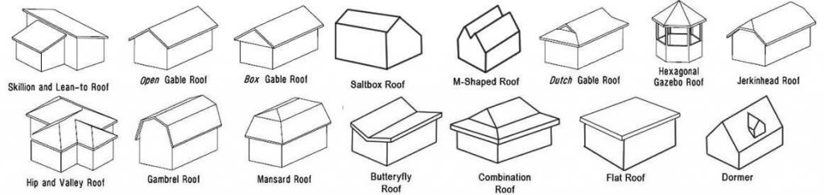

Type of Roof Covering (Tick): RCC / Corrugated Sheet / Tin

Age of Roof / Roof Covering [a]:

Access to Roof: Difficult ☐ Medium ☐ Easy ☐

