08 May 2025

To Whom It May Concern

SUBJECT: RFQ FOR SUPPLY OF UNIFORM FOR THE STAFFS OF IDCOL.

SCHEDULE OF ITEMS AND PRICED QUOTATION FOR
SUPPLY OF UNIFORM FOR THE STAFFS OF IDCOL

S/L | Description | Quantity | Unit Rate | Total Cost
1 | Uniform for staffs of IDCOL  (2 sets for each of the 26 staffs;  Each set consists of 1 pc of Shirt & 1 pc of Pant)  [Specs:  i) Shirt with embroidery logo of IDCOL  ii) Shirt Fabric: As per sample kept in IDCOL office  (100% cotton fabric similar or equivalent to Thailand Sonobaryo)  iii) Pant Fabric: As per sample kept in IDCOL office  (65% Cotton & 35% Tetron similar or equivalent to Indian Bently)] | 52 sets
Grand Total (including applicable Tax as per slab and VAT (10%))
In Words:

_______________________________
Company Seal & Signature
Date:
Note:
- Quotation must be valid for 30 days from the date of submission deadline.
- Quotationer, in support of its qualification shall be required to submit photocopies of latest documents related to valid Trade License, Tax Identification Number (TIN) and VAT Registration Number; without which the Quotation may be considered non-responsive.
- Only hard copy of the Quotations are acceptable. Quotations submitted via email shall be rejected.
- Quotationer shall submit sample fabrics as per the required technical specifications along with the quotation.
- Interested vendors may visit IDCOL office (address given below) during office hours (10:00 am to 6:00 pm) to inspect the fabric sample.
- Submission Deadline: On Or Before 18 May 2025 – 5:00 PM at below mentioned address.

Sudipto Khatib
Manager, Procurement
Infrastructure Development Company Limited
UTC Building (Level-16), 8 Panthapath, Kawran Bazar, Dhaka-1215
Tel: 9102171-8 (EXT: 6400), Mobile: 017199-06983; email: khatib@idcol.org

Technical Specification of the Goods Required
- Each set consists of 1 pc of Shirt & 1 pc of Pant)
- Shirt with embroidery logo of IDCOL
- Shirt Fabric: As per sample kept in IDCOL office (100% cotton fabric similar or equivalent to Thailand Sonobaryo).
- Pant Fabric: As per sample kept in IDCOL office (65% Cotton & 35% Tetron similar or equivalent to Indian Bently).
- Interested vendors may visit IDCOL office (address given below) during office hours (10:00 am to 6:00 pm) to inspect the fabric sample.
- Sample image for reference:

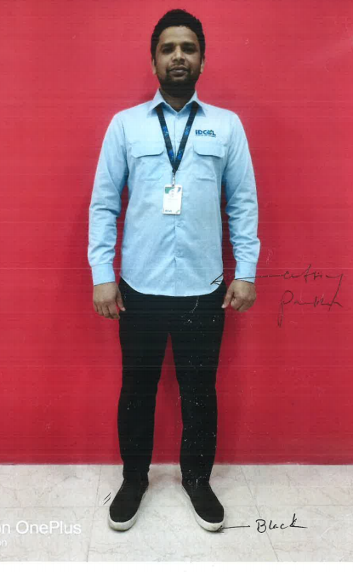

Terms and Conditions for Supply of Goods and Payment
- The Supplier will collect the tailoring measurements of the IDCOL staff from IDCOL’s office located at UTC Building, 8 Panthapath, Kawran Bazar, Dhaka-1215 within 04 working days of the issuance of the Work Order.

- The Supplier shall supply the manufactured uniforms to IDCOL’s office within 20 days of the issuance of the Work Order.

- Notwithstanding any other practice, the payment shall be based on the actual delivery of goods on the basis of the quantity of each item of Goods in accordance with the Priced Schedule and Specifications. 100% of the Contract price of the Goods and related services shall be paid after submission and acceptance of the Delivery Chalan.

- The Supplier’s rates or prices shall be inclusive of profit and overhead and all kinds of taxes, duties, fees, levies, and other charges to be paid under the Applicable Law.

- The Procuring Entity shall check and verify the delivery made by the Supplier in conformity with the Technical Specifications and notify the Supplier of any Defects found.

- If the Goods are found to be defective or otherwise not in accordance with the specifications, the Procuring Entity may reject the supplies by giving due notice to the Supplier, with reasons.

